|  |
| --- |
| EPAM Systems, RD Dep. |
| Materialized View |

|  |  |  |  |  |  |
| --- | --- | --- | --- | --- | --- |
| REVISION HISTORY | | | | | |
| Ver. | Description of Change | Author | Date | Approved | |
| Name | Effective Date |
| 1.0 | Initial status | Arina Marchenko | 4-DEC-2017 |  |  |

Contents

Materialized View 3

# 

# Materialized View

A materialized view in Oracle is a database object that contains the results of a query. They are local copies of data located remotely, or are used to create summary tables based on aggregations of a table's data. A materialized view can query tables, views, and other materialized views.

CREATE MATERIALIZED VIEW mv

BUILD IMMEDIATE

refresh force on demand

as SELECT

*

FROM bl_dm.dim_customers;

INSERT into bl_dm.dim_customers values (50001,

49177,

87965,

'Arina',

'Marchenko',

20,

'female',

'5698 20 78 98',

'arina_marchenko@epam.com',

SYSDATE);

EXECUTE DBMS_MVIEW.REFRESH ('MV');

SELECT *

FROM bl_dm.dim_customers

ORDER BY customer_did DESC;

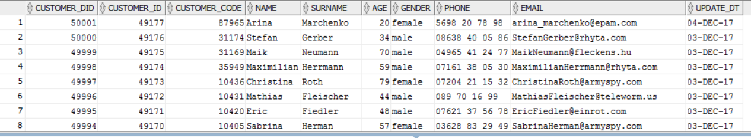

CREATE MATERIALIZED VIEW LOG ON bl_dm.dim_customers

WITH ROWID, SEQUENCE(dim_customers_seq) INCLUDING NEW VALUES;

INSERT into dim_customers values (50002,

49178,

87952,

'Slava',

'Marchenko',

18,

'male',

'5698 96 78 98',

'slava_marchenko@gmail.com',

SYSDATE);

